

Hypermedia Applications Project

IDM C/L/P Design Document

12/5/2016

Politecnico di Milano 5th School of Engineering

Contents

1. Purpose 3

2. Brief introduction 3

3. Conceptual design (C-IDM) 3

4. Logical Design (L-IDM) 5

5. Page design (P-IDM) 7

6. Interactive Mockup 9

7. Used tools 18

8. Working Hours 18

# Purpose

This document aims to describe the design and prototyping steps taken for implementing the web site for a large telecom company selling telecommunication infrastructures, devices and services assigned as part of a project of the “Hypermedia Applications (Web and Multimedia)” course at Politecnico di Milano.

# Brief introduction

The document provides detailed web application design procedure. Starting from the conceptual design, following up with logical design and, finally, page design. After page design is introduced, it is going to serve as the basis for interactive mock-up development and will be described at the end of this document. Explanation of all the symbols used can be found in the course's lesson slides.

# Conceptual design (C-IDM)

Conceptual design is made with respect to the specifications published in the reference document “Design Project Specifications” that was provided by professor. Short outline:

**SINGLE TOPICS**

1. WHO WE ARE

2. THE GROUP

**MULTIPLE TOPICS**

1. Device [10-100]

2. Smart Life (SL) Service [10-50]

3. Assistance Service [50]

**RELATIONSHIPS**

1. Available SL Service: Device →SL service [1, 5]

2. For device(s)_1: SL Service →Device [1-30]

3. Assistance for: Device →Assistance service [1, 10]

4. For device(s)_2: Assistance Service →Device [1-10]

**MULTIPLE GROUPS**

1. DEVICES BY CATEGORY[5]

2. SMART LIFE SERVICES BY CATEGORY [4]

3. ASSISTANCE SERVICES BY CATEGORY [4, N]

**GROUPS**

1. PROMOTIONS (for devices)

2. ALL DEVICES

3. ALL SL SERVICES

4. ALL ASSISTANCE SERVICES

5. HIGHLIGHTS

Following is the C-IDM diagram:

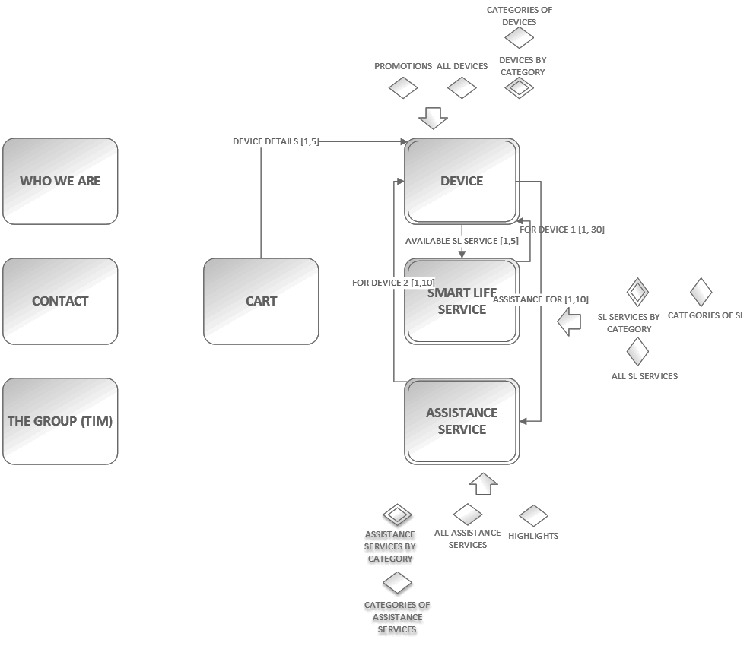

Figure 3.1 - Conceptual IDM schema

# Logical Design (L-IDM)

Logical design enhance C-IDM scheme by introducing content dialogue acts. Content dialogue acts can be perceived as Question and Answer form of interaction with the user. User asks the question about the content, and the system (web application) returns the contents that user asked for. Short outline:

**SINGLE TOPICS**

**1. WHO WE ARE**

* *Innovation*
* *Testimonials*
* *Projects*

**2. THE GROUP**

* *Group Description*
* *News*
* *Governance*
* *Business & Market*
* *For Investors*

**3. Device**

* *Presentation*
* *Technical Characteristics*

**4. Smart Life (SL) Service**

* *Description*
* *Activation and Rules*
* *(Optional) FAQ*

**5. Assistance Service**

* *Description*

Some other content dialogue acts were added to topics in order to completely describe them, like for example Device with image and description. We may pay attention to both, content dialogue acts which further describe our topics and multiple topics, in L-IDM schema (*fig 4.1.*), and to Relevant Relations that have cardinality value greater than one. Relevant relations that have cardinality equal to one are simple to implement, one simple link leading to other side of relation. The ones with cardinality greater than one require an additional transitional page in P-IDM schema. More about it in the next section. On the next figure L-IDM diagram is shown.

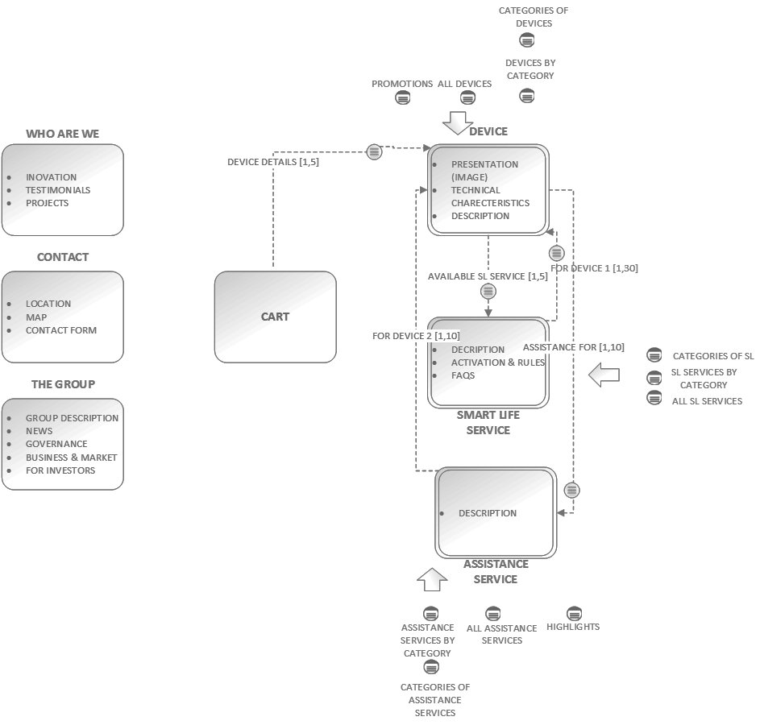

Figure 4.1 - Logical IDM schema

# Page design (P-IDM)

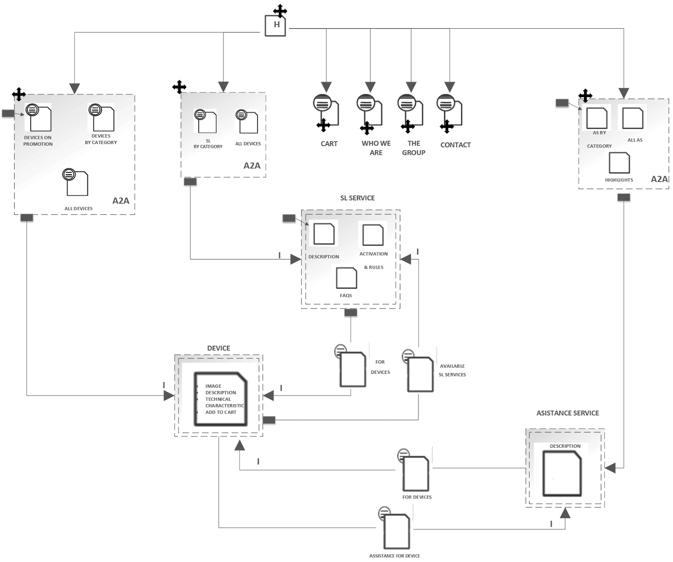

Figure 5.1 - Page IDM schema

In P-IDM our attention is focused on the implementation of our pages of web application. We need to convert entities from L-IDM schema to real html pages (at least to their high-level structures) and navigation links that will constitute our P-IDM schema. The cross symbol next to page represents that page is a landmark, that is, a page that is always accessible through navigation menu no matter on which page we are positioned. For simple pages on the right there is not much to say, but some pages on the left require a more thorough explanation.

For example, group of pages in the upper left side of the diagram in a dashed rectangle are also landmarks. Once a user clicks on that landmark he lands on the default page *“Devices by category”,* represented as the grey rectangle with a pointing arrow towards the Devices page, opened tab Promotion devices. This group has the A2A pattern, which means that all pages in a group are connected by navigational links among each other. From there we can reach Device multiple topic page by indexed navigation.

There are also Transition pages present in P-IDM schema, they represent an introduction of a page that user want to visit. In our P-IDM schema those transition pages are *FOR DEVICES, AVAILABLE SL SERVICES and ASSISTANCE FOR DEVICES.*

# Interactive Mockup

As the last step in the design process, we derive an interactive mockup from P-IDM (fig 5.1.) keeping in mind the goals of our contractors, stakeholders of Telecom company (promotion and conveying information clearly) and that of our end-users, Telecom company's clients (getting all their questions answered). For the sake of readability all images will be a smaller than original size. You can, however, find a full interactive mockup in html format in the " .Web/" subdirectory.

Starting with the Home Page (fig 6.1), right below the web application's title is a navigation bar incorporating all landmark pages stated in P-IDM as navigation links. The same navigation element is used across all pages, and as such won't be mentioned in the sections that follow. Along with some descriptive elements like "Contact" and "Who We Are" (About Us segment), Home Page also contains links to "Devices" and "Smart Life" and “Assistance” which lead to multiple topic pages for devices, smart life services and assistance services respectively.

The page is designed as a single pager with sections. Content for each section is a short text description. News is implemented as a scroll through recent news posts. About Us segment, which corresponds to Who We Are in the L - IDM has a short description which can be expanded by clicking more link. Contact Us segment contains two part: contact form (through which a user can send an email) and a map of close by shops.

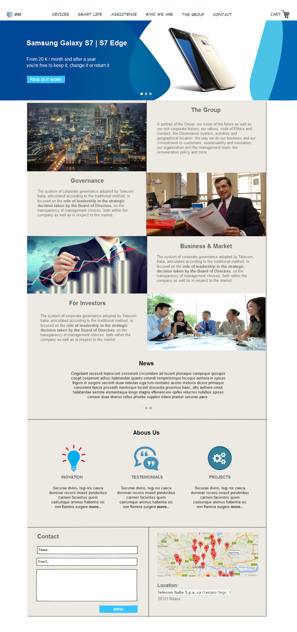

Figure 6.1 Home Page

*Devices page* is a landmark page which means that is reachable at any time.  From *fig 6.2* we can see the element in the leftmost corner reading "Home > Devices" informing the user from which page he navigated here. To improve user experience we separately displayed into two tabs Promotion devices and devices by category respectively.

Promoted devices, Promotion tab, contains most popular devices which contains special offer, in that tab category search menu on the left is disabled. In every device frame we can see picture of the device, price and details button, click on that button leads to *Device details page (see fig 6.5).*

Category tab contains all devices, with an option of filtering. The user can see category menu on the left and by checking this options he will see refreshed list of devices filtered by selected categories.

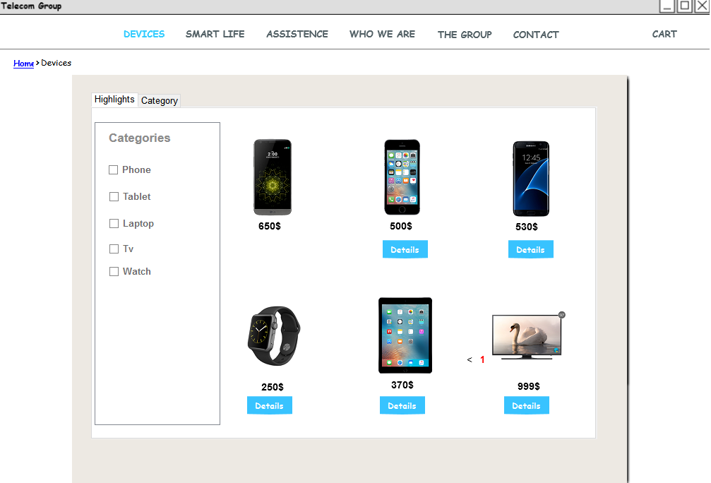

*Figure 6.2 - Devices Page*

*Smart Life Services page* (*fig 6.3*) can be reached through landmark at any time. This is a transition page to single topic pages of Smart Life Services. It is a list of categories of Smart Life Services. It consists of 4 segments each containing a short text description and a link to the detailed page.

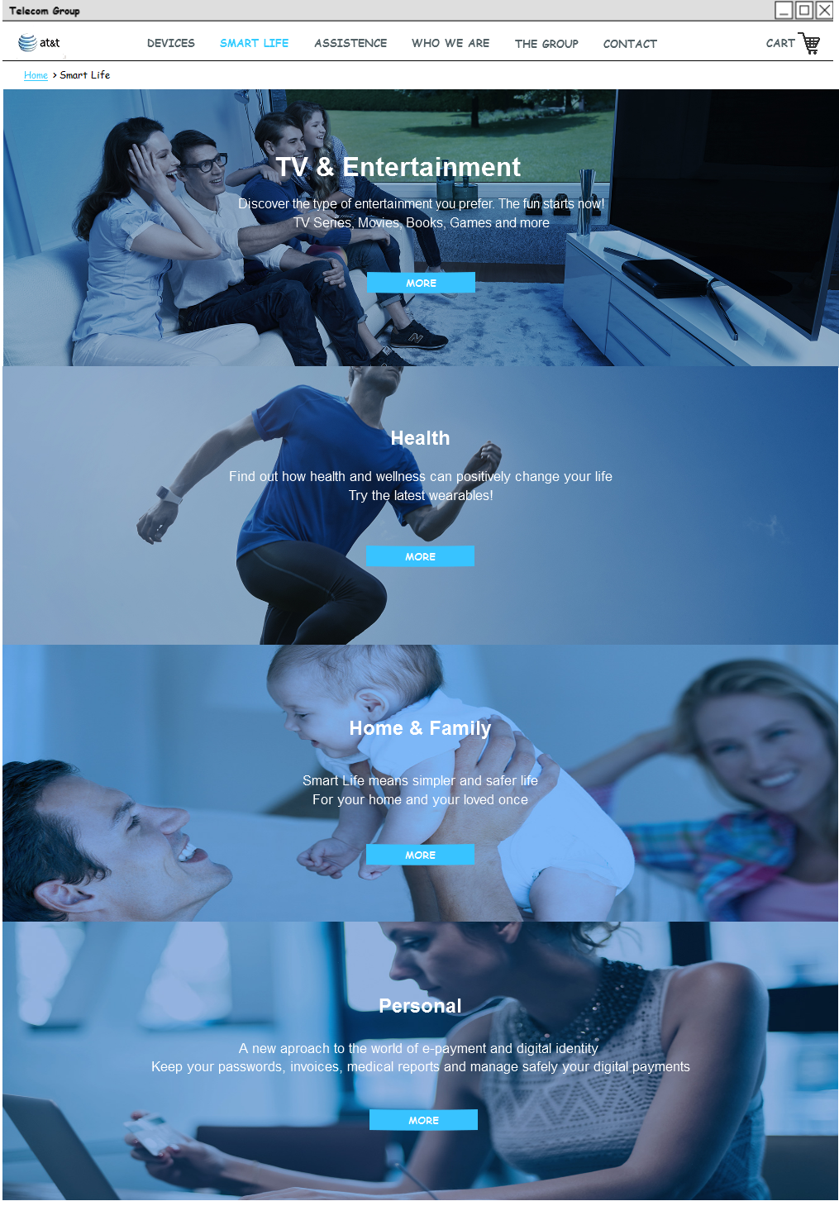

*Figure 6.3 - Smart Life Services Page*

*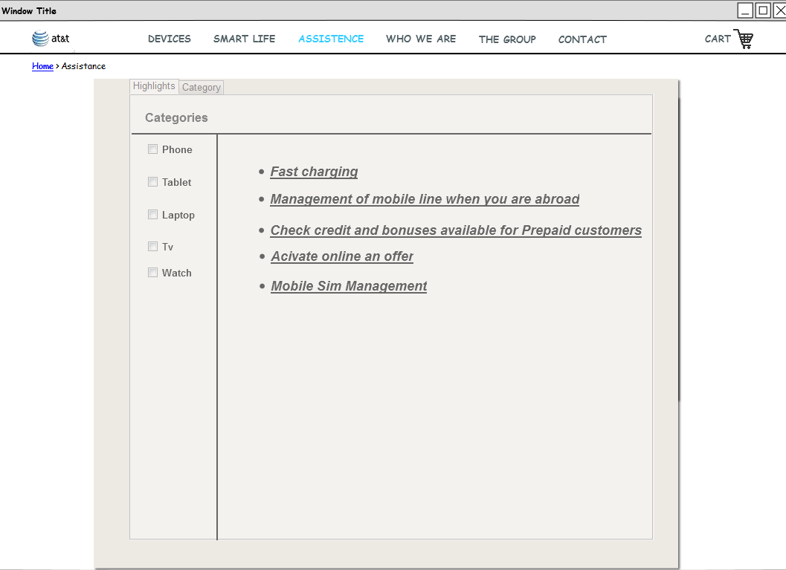Figure 6.4 - Assistance Page*

*Device details page,* not a landmark, can be reached through *Devices page, SL details page* or *Assistance details page* by selecting one of the listed devices clicking on device image or device name. From *fig. 6.5* we can see in the upper left corner the website path that took us to Device details page (for example “*Home > Devices > Samsung Galaxy S6 Edge”*). You are able to navigate through the path and visit the pages that brought you to Device details page. In the middle area of the page device image is shown as well as short device description. In the right down corner is tab container that has three tabs: Technical Specification, Smart Life Services and Assistance Services. In the Technical Specification tab is listed device configuration. Switching to Smart Life Services you will get list of Smart Life Services that are related to this particular device, similar stands for Assistance Services. Considering the similarity between Smart Life details page and Device details page, we have decided not to elaborate the Smart Life details page in order to get more concise Design document.

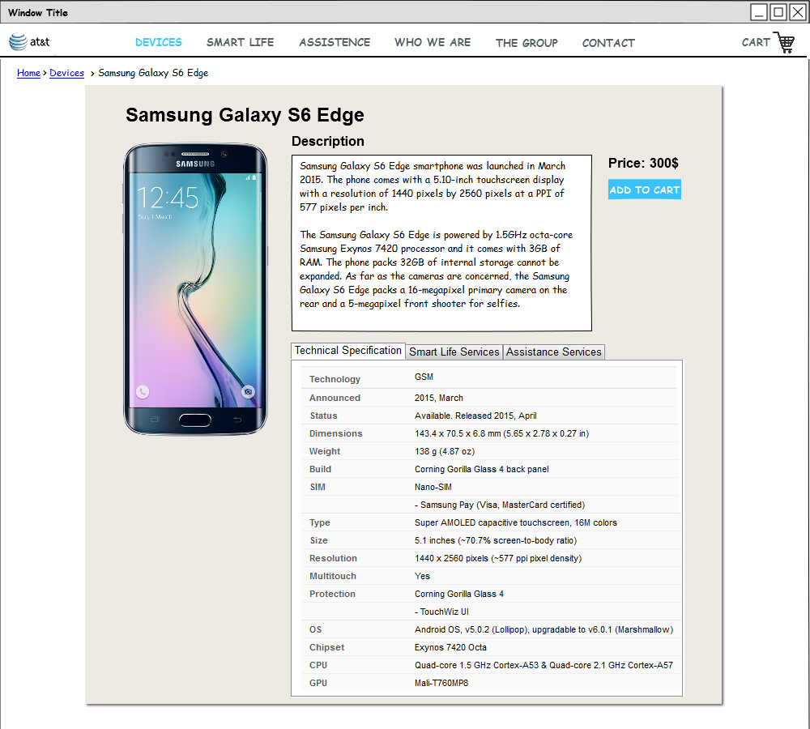

*Figure 6.5 - Device details Page*

*Assistance details page,* as well not a landmark page, could be reached through *Assistance page* by selecting one link from the listed ones. From *fig. 6.6* we can see that the Assistance details page contains as well a web path which represents how user came to particular Assistance details page. Navigating through the path user could end up on pages shown in the path. Main part of the page is the description of the Assistance service which contains detailed description of the particular service. In the bottom part of the page a list of device connected to this particular service is shown. By clicking on the device image or the device name, user is redirected to selected device detail page.

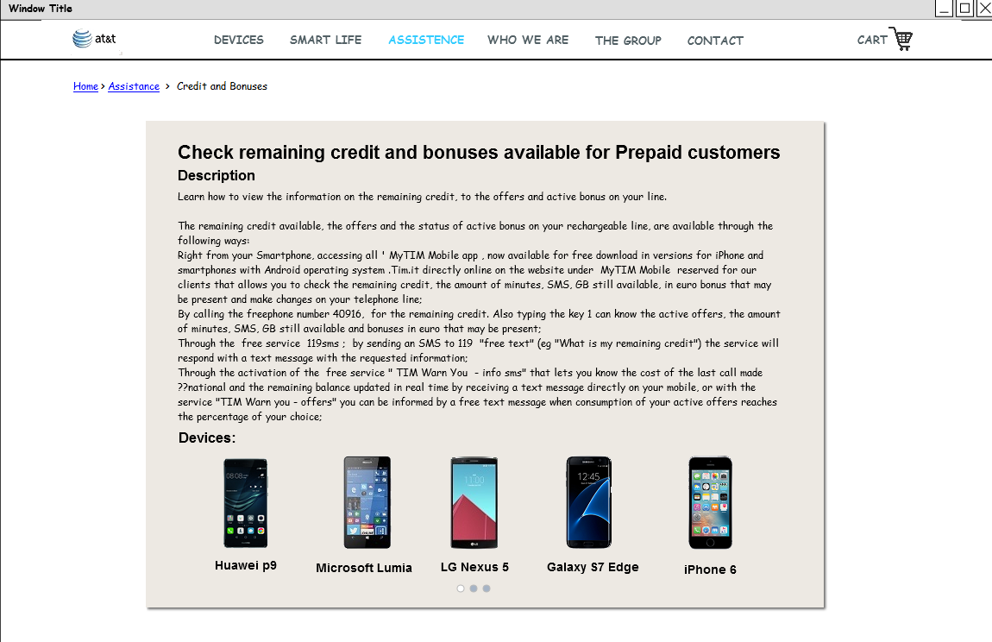

*Figure 6.6 - Assistance details Page*

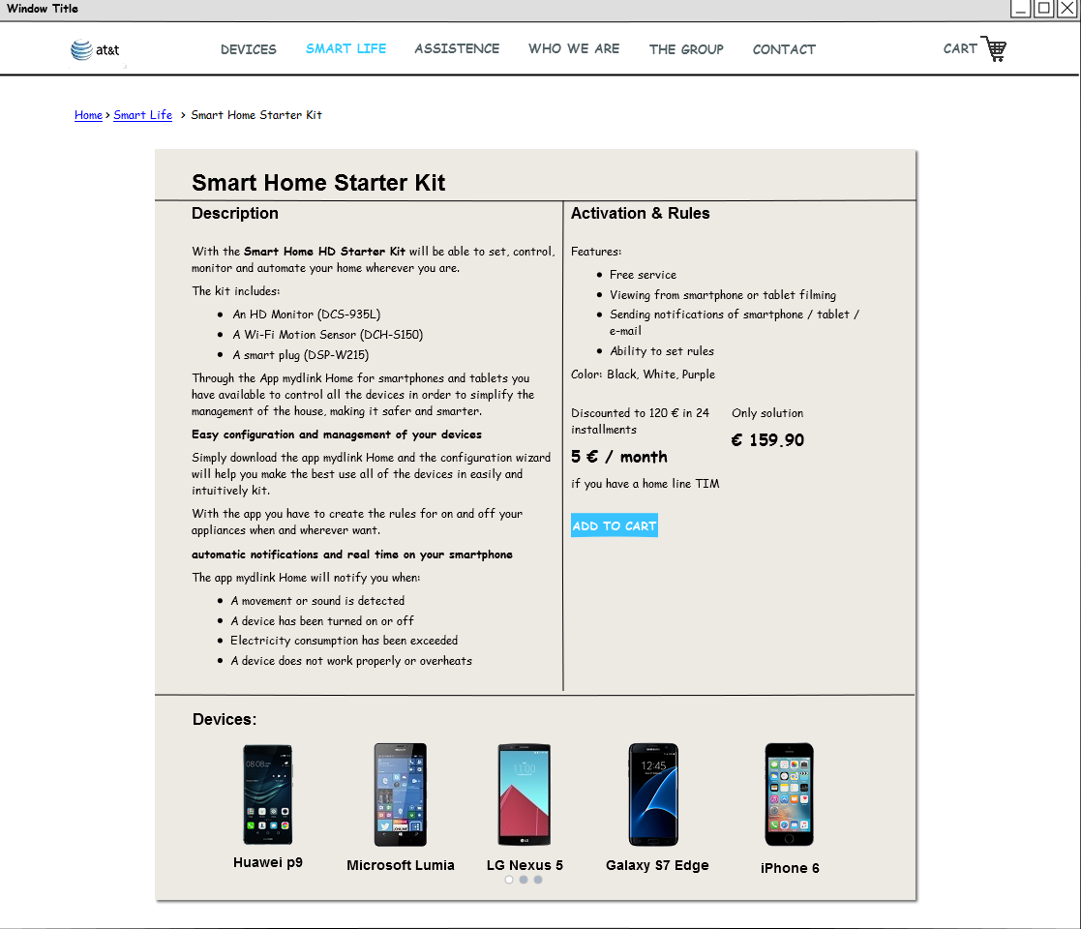

*Figure 6.7 - Smart Life details Page*

*Cart page* is also landmark page since the user should be always able to see it. The cart page can be accessed by clicking on the cart image in top right corner of a page.  In top left corner we can see from where we accessed the cart. The main part of a page contains table of items, accumulated cost of all items and a checkout button. The item can be removed from list by clicking on radio button in the same row.

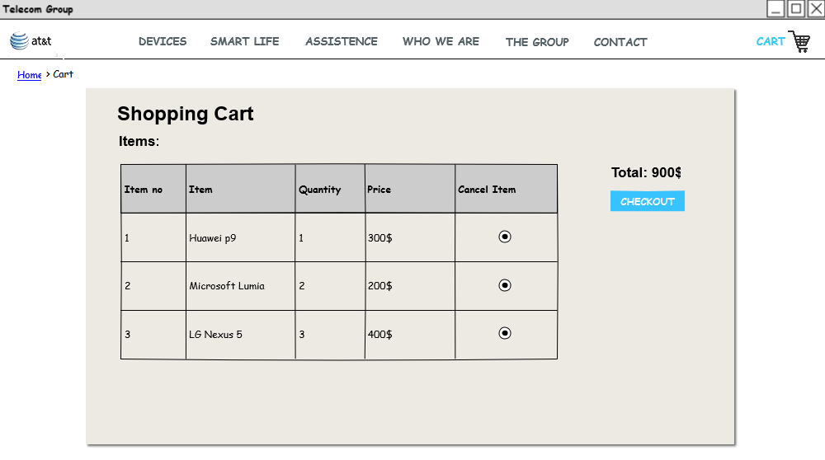

*Figure 6.8 - Shopping Cart Page*

# Used tools

* Microsoft Office Word
* Adobe Photoshop
* Pencil
* Git

# Working Hours

|  |  |
| --- | --- |
| **Name** | **Working hours** |
| Jovanovic Milica | 15 hours |
| Korda Petar | 15 hours |
| Vidanovic Pavle | 15 hours |